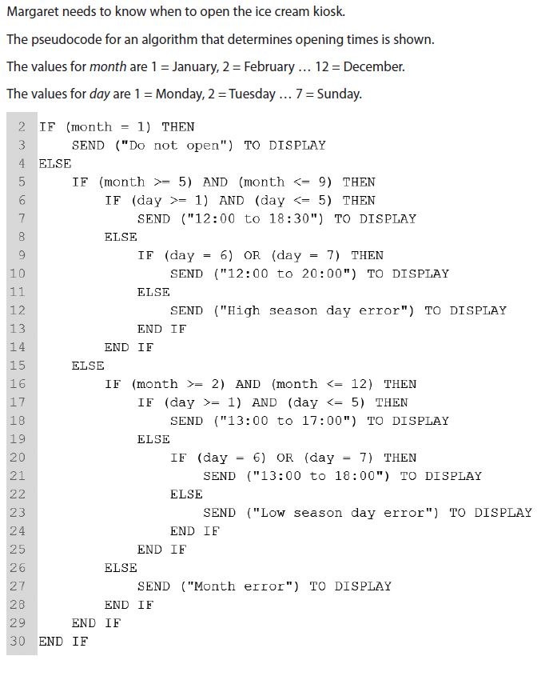Q1.

1. Complete the table to show the output of the pseudocode algorithm, based on the given inputs.

|  |  |  |
| --- | --- | --- |
| **Input** | | **Output Displayed** |
| **Month** | **Day** |
| **1** | **5** | Do not open |
| **6** | **4** | 13:00 to 17:00 |
| **3** | **7** | 12:00 to 20:00 |

1. The pseudocode algorithm needs to be tested.

Construct test data to meet the requirements set out in the table.

|  |  |  |
| --- | --- | --- |
| **Input** | | **Requirement** |
| **Month** | **Day** |
| 6 | 6 | **A condition generating ‘12:00 to 20:00’** |
| 13 | 1 (any number) | **A condition generating ‘Month error’** |
| 11 | 8 | **A condition generating ‘Low season day error’** |

(c). Implement the pseudocode in Python and show the test results using data in part(b).

**Code:**

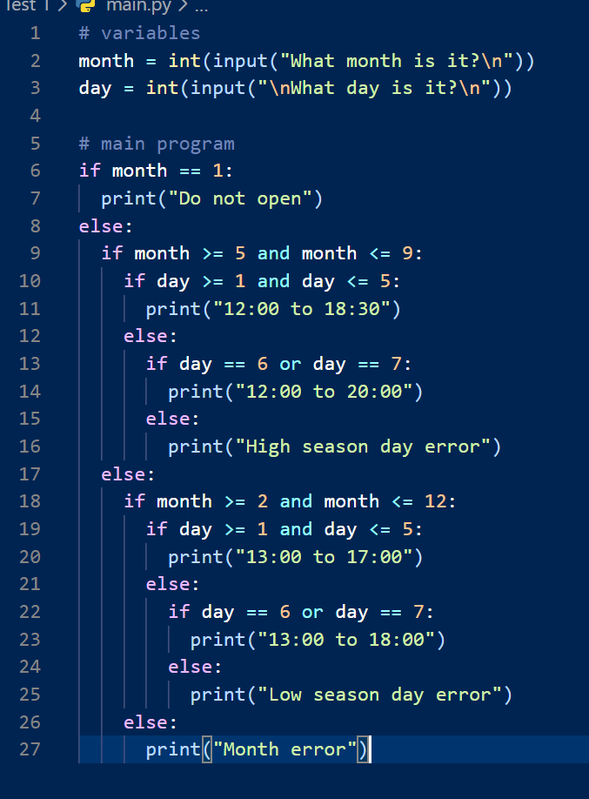

**\***results are shown below**\***

**Results:**

